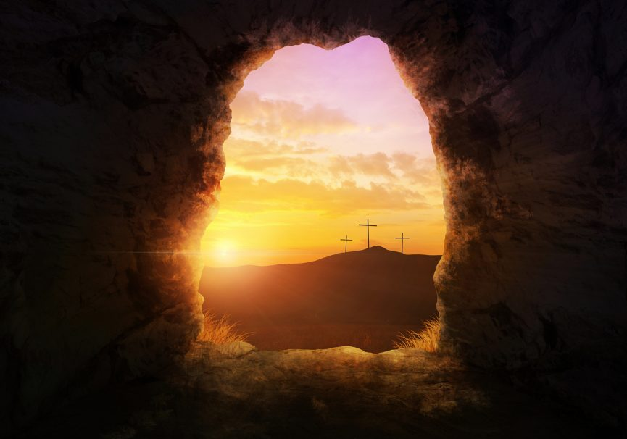

Holy Communion for
Easter

The Greeting

Grace, mercy and peace from God our Father
and the Lord Jesus Christ be with you.
And also with you.

Alleluia. Christ is risen.
He is risen indeed. Alleluia.
Words of welcome or an introduction may be said
Prayer of Preparation

Almighty God,
to whom all hearts are open,
all desires known,
and from whom no secrets are hidden:
cleanse the thoughts of our hearts
by the inspiration of your Holy Spirit,
that we may perfectly love you,
and worthily magnify your holy name;
through Christ our Lord. Amen.
Confession
As we come before God together,
let’s keep a moment of quiet and
offer to his love and mercy our sadness
for the times when we have not loved him
and have not loved each other.
Christ our Passover lamb has been sacrificed for us. Let us therefore rejoice by putting away all malice and evil and confessing our sins with a sincere and true heart.
Almighty God, our heavenly Father,
we have sinned against you
and against our neighbour
in thought and word and deed,
through negligence, through weakness,
through our own deliberate fault.
We are truly sorry and repent of all our sins.
For the sake of your Son Jesus Christ,
who died for us, forgive us all that is past
and grant that we may serve you in newness of life
to the glory of your name.
Amen.

Almighty God, who forgives all who truly repent,
have mercy upon you,
pardon and deliver you from all your sins,
confirm and strengthen you in all goodness,
and keep you in life eternal;
through Jesus Christ our Lord. Amen

The Gloria

Glory to God in the highest,
and peace to his people on earth.
Lord God, heavenly King,
almighty God and Father,
we worship you, we give you thanks,
we praise you for your glory.
Lord Jesus Christ, only Son of the Father,
Lord God, Lamb of God,
you take away the sin of the world:
have mercy on us;
you are seated at the right hand of the Father:
receive our prayer.
For you alone are the Holy One,
you alone are the Lord,
you alone are the Most High, Jesus Christ,
with the Holy Spirit,
in the glory of God the Father.
Amen.

The Collect

The Liturgy of the Word

Readings
For the word of the Lord.
Thanks be to God

This is the Gospel of the Lord
Praise to you, O Christ.

Gospel Reading
We stand and when the Gospel is announced the reader says
The Lord be with you

And also with you.

Hear the Gospel of our Lord Jesus Christ according to N.

Glory to you, O Lord.

At the end

This is the Gospel of the Lord.

Praise to you, O Christ.

Sermon
The Creed
Let us affirm our faith in Jesus Christ, the Son of God

Though he was divine,
he did not cling to equality with God,
but made himself nothing.
Taking the form of a slave,
he was born in human likeness.
He humbled himself
and was obedient to death,
even the death of the cross.
Therefore God has raised him on high,
and given him the name above every name:
that at the name of Jesus every knee shall bow,
and every voice proclaim that Jesus Christ is Lord
to the glory of God the Father. Amen

Prayers of Intercession
Lord, in your mercy
Hear our prayer

Merciful Father,
accept these prayers
for the sake of your Son, our Saviour Jesus Christ. Amen.
The Liturgy of the Sacrament
The Peace
The risen Christ came and stood among his disciples
and said, ‘Peace be with you’.
Then they were glad when they saw the Lord.

Alleluia! The peace of the risen Lord be always with you.
And also with you. Alleluia!

Preparation of the Table

Yours, Lord, is the greatness, the power,
the glory, the splendour and the majesty;
for everything in heaven and on earth is yours.
All things come from you
and of your own do we give you

The Eucharistic Prayer
The Lord be with you.
And also with you.

Lift up your hearts.
We lift them to the Lord.

Let us give thanks to the Lord our God.
It is right to give him thanks and praise.

It is right to praise you, Father, Lord of all creation;
in your love you made us for yourself.
When we turned away
you did not reject us,
but came to meet us in your Son.
You embraced us as your children
and welcomed us to sit and eat with you.

In Christ you shared our life
that we might live in him and he in us.
He opened his arms of love upon the cross
and made for all the perfect sacrifice for sin.

On the night he was betrayed,
at supper with his friends
he took bread, and gave you thanks;
he broke it and gave it to them, saying:
Take, eat; this is my body which is given for you;
do this in remembrance of me.
Father, we do this in remembrance of him:
his body is the bread of life.

At the end of supper, taking the cup of wine,
he gave you thanks, and said:
Drink this, all of you; this is my blood of the new covenant,
which is shed for you for the forgiveness of sins;
do this in remembrance of me.
Father, we do this in remembrance of him:
his blood is shed for all.

As we proclaim his death and celebrate his rising in glory,
send your Holy Spirit that this bread and this wine
may be to us the body and blood of your dear Son.
As we offer these holy gifts
make us one in Christ, our risen Lord.

With your whole Church throughout the world
we offer you this sacrifice of praise
and lift our voice to join the eternal song of heaven:

Holy, holy, holy Lord,
God of power and might,
heaven and earth are full of your glory.
Hosanna in the highest.
Blessed is He who comes in the name of the Lord.
Hosanna in the highest.
The Lord’s Prayer
Rejoicing in the Lord’s undying love for us, let us pray with confidence as our Saviour taught us
Our Father,
who art in heaven,
hallowed be thy name.
Thy kingdom come.
Thy will be done
on earth as it is in heaven.
Give us this day our daily bread
And forgive us our trespasses,
as we forgive those
who trespass against us.
And lead us not into temptation,
but deliver us from evil.
For thine is the kingdom
the power and the glory,
for ever and ever.
Amen.
The Breaking of the Bread
The president breaks the consecrate bread
Lamb of God, you take away the sin of the world,
have mercy upon us,
Lamb of God, you take away the sin of the world
have mercy upon us,
Lamb of God, you take away the sin of the world,
grant us Peace.

Giving of Communion

Alleluia, Christ our Passover is sacrificed for us.
Therefore let us keep the feast. Alleluia.

After Communion
A Post Communion prayer is said by the president and then we say together
Father of all,
we give you thanks and praise, that when we were still far off
you met us in your Son and brought us home. Dying and living, he declared your love,
gave us grace, and opened the gate of glory.
May we who share Christ’s body live his risen life; we who drink his cup bring life to others;
we whom the Spirit lights give light to the world. Keep us firm in the hope you have set before us, so we and all your children shall be free,
and the whole earth live to praise your name; through Christ our Lord. Amen.

The Blessing

The God of peace
who brought again from the dead our Lord Jesus Christ
that great shepherd of the sheep
through the blood of the eternal covenant,
make you perfect in every good work to do his will,
working in you that which is well pleasing in his sight.
And the blessing of God the father and the Son and the
Holy Spirit be with you now and forever.
Amen

Go in the peace of Jesus, Alleluia, Alleluia.
Thanks be to God. Alleluia, alleluia.

