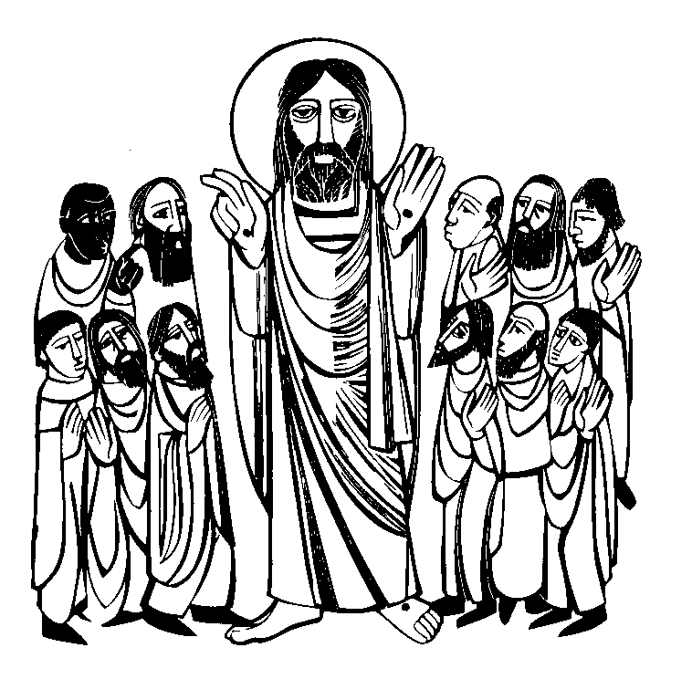

The Season of Easter
Easter is the most important Christian Festival in the year and is called ‘The Queen of Festivals.’ It’s a time of joy and confidence as we celebrate Jesus’ victory over death and share in his resurrection. Death is not the end, but the beginning of a new life. The Easter Season lasts for seven weeks until Ascension Day. For those Christians who have journeyed through Lent the Easter season is one of great contrast.

What to look and listen for
The reappearance of glorious floral decorations, the white and gold robes and coverings and most of all the newly blessed Easter candle, symbolizing the light of Christ in an often dark and perplexing world.

The sound of Easter is ALLELUIA as in word and song we praise God for the resurrection of Jesus and sing our hearts out.

Preparing for Worship
It’s good to spend time in quiet preparation before the service begins and especially during the last five minutes. This is an opportunity to read through the words of the hymns and the Bible readings on the weekly sheet and to pray that God will speak to you.

You may also find the following prayer useful.

Lord Jesus, stand among us now in your risen power; make yourself known to us
in the breaking of the bread
and the opening of the scriptures, so that we may worship you
in spirit and in truth
for your name’s sake. Amen.

THE GATHERING

Words in bold print are said by everyone.

A HYMN is announced and we all STAND

The president says

In the name of the Father, and of the Son,
and of the Holy Spirit.
Amen.

The Greeting

The president greets the people

The Lord be with you

and also with you.

Alleluia. Christ is risen.

He is risen indeed. Alleluia.

Words of welcome or introduction may be said.

Prayer of Preparation
Almighty God,
to whom all hearts are open,
all desires known,
and from whom no secrets are hidden:
cleanse the thoughts of our hearts
by the inspiration of your Holy Spirit,
that we may perfectly love you,
and worthily magnify your holy name;
through Christ our Lord. Amen.

Prayers of Penitence

Led by the president or a minister

Everyone KNEELS or SITS

Christ our Passover lamb has been sacrificed for us. Let us therefore rejoice by putting away all malice and evil and confessing our sins with a sincere and true heart.
1 Corinthians 5. 7, 8

Almighty God, our heavenly Father,
we have sinned against you and against our neighbour in thought and word and deed,
through negligence, through weakness, through our own deliberate fault.

We are truly sorry and repent of all our sins. For the sake of your Son Jesus Christ,
who died for us,
forgive us all that is past
and grant that we may serve you in newness of life to the glory of your name. Amen.

The president declares God’s forgiveness

Almighty God,
who forgives all who truly repent, have mercy upon you,
pardon and deliver you from all your sins, confirm and strengthen you in all goodness, and keep you in life eternal;
through Jesus Christ our Lord. Amen.

The Gloria

Everyone STANDS

Glory to God in the highest,
and peace to his people on earth.

Lord God, heavenly King, almighty God and Father,
we worship you, we give you thanks, we praise you for your glory.

Lord Jesus Christ, only Son of the Father, Lord God, Lamb of God,
you take away the sin of the world: have mercy on us;
you are seated at the right hand of the Father: receive our prayer.

For you alone are the Holy One, you alone are the Lord,
you alone are the Most High, Jesus Christ, with the Holy Spirit,
in the glory of God the Father. Amen.

The Collect
A penitent and forgiven people now enter deeper into prayer using the collect on the front of the weekly sheet. As we REMAIN STANDING the president introduces a period of silence with the words “Let us pray” during which we quietly read the collect before praying it together.

Everyone SITS

THE LITURGY OF THE WORD
Readings
There may be one or two readings from the Bible. At the end of each the reader says

This is the word of the Lord.

Thanks be to God.

A brief period of silent reflection follows the reading(s) and then a HYMN, ANTHEM or PSALM may be said or sung

Gospel Reading

Everyone STANDS when the President stands. When the Gospel is announced the reader says The Lord be with you

And also with you.

Hear the Gospel of our Lord Jesus Christ according to N.

Glory to you, O Lord.

At the end

This is the Gospel of the Lord.

Praise to you, O Christ.

Sermon

At the end of the sermon a period of silence is kept for reflection.
Everyone then STANDS when the president stands.

The Creed
This statement of belief was first issued in 325AD to distinguish Christianity from other beliefs and heresies.

Let us affirm our faith in God, who is Father, Son and Holy Spirit

We believe in one God, the Father, the Almighty,
maker of heaven and earth, of all that is,
seen and unseen.
We believe in one Lord, Jesus Christ, the only Son of God,
eternally begotten of the Father, God from God, Light from Light, true God from true God, begotten, not made,
of one Being with the Father; through him all things were made.
For us and for our salvation he came down from heaven, was incarnate from the Holy Spirit and the Virgin Mary and was made man.
For our sake he was crucified under Pontius Pilate; he suffered death and was buried.
On the third day he rose again
in accordance with the Scriptures; he ascended into heaven
and is seated at the right hand of the Father.
He will come again in glory to judge the living and the dead, and his kingdom will have no end.

We believe in the Holy Spirit, the Lord, the giver of life,
who proceeds from the Father and the Son,
who with the Father and the Son is worshipped and glorified, who has spoken through the prophets.
We believe in one holy catholic and apostolic Church. We acknowledge one baptism for the forgiveness of sins. We look for the resurrection of the dead,
and the life of the world to come. Amen.

Prayers of Intercession

Everyone KNEELS or SITS
The prayers usually include these concerns The Church of Christ
Creation, human society, the Sovereign and those in authority The local community
Those who suffer
The communion of saints These responses may be used
Lord, in your mercy

hear our prayer.

Or

Lord hear us

Lord graciously hear us

And at the end Merciful Father,
accept these prayers

for the sake of your Son,
our Saviour Jesus Christ. Amen.

THE LITURGY OF THE SACRAMENT
The Peace
Everyone STANDS

The words and actions that follow symbolise the command of Jesus to be reconciled to one another before receiving Communion which represents our reconciliation with God.

The risen Christ came and stood among his disciples And said, ‘Peace be with you.’
Then were they glad when they saw the Lord.
John 20. 19, 20

Alleluia! The peace of the risen Lord be always with you

And also with you. Alleluia!

[Let us offer one another a sign of peace.]

Everyone may exchange a sign of peace with those around them, for example by shaking hands and saying ‘Peace be with you’

Preparation of the Table
A HYMN is sung during which the bread and wine are presented. The altar is prepared and a collection is taken and offered. At the end of the hymn the president takes the bread and wine into their hands, and these words are said

Yours, Lord, is the greatness, the power,
the glory, the splendour, and the majesty;
for everything in heaven and on earth is yours.
All things come from you,
and of your own do we give you.

The Eucharistic Prayer
Everyone remains STANDING

The Lord is here

His Spirit is with us

Lift up your hearts

We lift them to the Lord

Let us give thanks to the Lord our God

It is right to give thanks and praise

It is indeed right, our duty and our joy, always and everywhere to give you thanks, almighty and eternal Father,
and in these days of Easter
to celebrate with joyful hearts
the memory of your wonderful works. For by the mystery of his passion Jesus Christ, your risen Son,
has conquered the powers of death and hell
and restored in men and women the image of your glory.
He has placed them once more in paradise and opened to them the gate of life eternal. And so, in the joy of this Passover,
earth and heaven resound with gladness,
while angels and archangels and the powers of all creation sing for ever the hymn of your glory:

Holy, holy, holy Lord,
God of power and might,
heaven and earth are full of your glory.
Hosanna in the highest.

Blessed is he who comes in the name of the Lord.
Hosanna in the highest.

Everyone KNEELS or SITS and may then watch as the president in word and action recalls Jesus’ Last Supper with his disciples.

Accept our praises, heavenly Father, through your Son our Saviour Jesus
Christ,
and as we follow his example and obey his command, grant that by the power of your Holy Spirit
these gifts of bread and wine
may be to us his body and his blood;

who, in the same night that he was betrayed, took bread and gave you thanks;
he broke it and gave it to his disciples, saying: Take, eat; this is my body which is given for you; do this in remembrance of me.

To you be glory and praise for ever.
In the same way, after supper
he took the cup and gave you thanks; he gave it to them, saying:
Drink this, all of you;
this is my blood of the new covenant,
which is shed for you and for many for the forgiveness of sins. Do this, as often as you drink it in remembrance of me.

To you be glory and praise for ever.
Therefore, heavenly Father,
we remember his offering of himself made once for all upon the cross;
we proclaim his mighty resurrection and glorious ascension; we look for the coming of your kingdom,
and with this bread and this cup
we make the memorial of Christ your Son our Lord. Praise to you, Lord Jesus:

Dying you destroyed our death, rising you restored our life: Lord Jesus, come in glory.

Accept through him, our great high priest, this our sacrifice of thanks and praise, and as we eat and drink these holy gifts in the presence of your divine majesty, renew us by your Spirit,
inspire us with your love
and unite us in the body of your Son, Jesus Christ our Lord.

To you be glory and praise for ever.

Through him, and with him, and in him, in the unity of the Holy Spirit,
with all who stand before you in earth and heaven, we worship you, Father almighty,
in songs of everlasting praise:

Blessing and honour and glory and power be yours for ever and ever. Amen.

The Lord’s Prayer
Let us pray with confidence as our Saviour has taught us;

Our Father, who art in heaven
hallowed be thy name,
thy kingdom come, thy will be done,
on earth as it is in heaven.
Give us this day our daily bread,
and forgive us our trespasses
as we forgive those who trespass against us.
And lead us not into temptation
but deliver us from evil.
For thine is the kingdom,
the power, and the glory,
For ever and ever. Amen.

Breaking of the Bread

The president breaks the consecrated bread.

We break this bread
to share in the body of Christ.

Though we are many, we are one body, because we all share in one bread.

The Agnus Dei may be sung

Lamb of God, you take away the sins of the world have mercy on us.
Lamb of God, you take away the sins of the world have mercy on us.
Lamb of God, you take away the sins of the world grant us peace.

Giving of Communion
The president says the invitation to communion

Draw near with faith.
Receive the body of our Lord Jesus Christ which he gave for you,
and his blood which he shed for you.
Eat and drink
in remembrance that he died for you, and feed on him in your hearts
by faith with thanksgiving.

Alleluia, Christ our passover lamb is sacrificed for us.

Therefore let us keep the feast. Alleluia.

The president receives Holy Communion, gives it to the other ministers and then to all other communicants. If you wish to receive a blessing you are very welcome to come forward - please carry this booklet in your hand to indicate this.

A HYMN is sung
Prayer after Communion
The ministers return to their places and the president says

Let us pray

A Post Communion prayer may be said by the president before the following prayer is said by everyone

Father of all,
we give you thanks and praise, that when we were still far off
you met us in your Son and brought us home. Dying and living, he declared your love,
gave us grace, and opened the gate of glory.
May we who share Christ’s body live his risen life;
we who drink his cup bring life to others;
we whom the Spirit lights give light to the world. Keep us firm in the hope you have set before us,
so we and all your children shall be free,
and the whole earth live to praise your name; through Christ our Lord. Amen.

A HYMN is sung

The Blessing
The Lord be with you

And also with you

The God of peace,
who brought again from the dead our Lord Jesus, that great shepherd of the sheep,
through the blood of the eternal covenant,
make you perfect in every good work to do his will, working in you that which is well-pleasing in his sight; and the blessing of God almighty,
the Father, the Son, and the Holy Spirit,
be among you and remain with you always. Amen.

THE DISMISSAL

A minister says
Go in peace to love and serve the Lord. Alleluia! Alleluia!

In the name of Christ. Alleluia! Alleluia!

The choir and ministers recess to the choir vestry.

PLEASE LEAVE THIS ORDER OF SERVICE IN CHURCH

Common Worship: Services and Prayers for the Church of England, material from which is included in this service, is copyright:
© The Archbishop’s Council 2000.

