The Baptism of Christ

10 January 2021

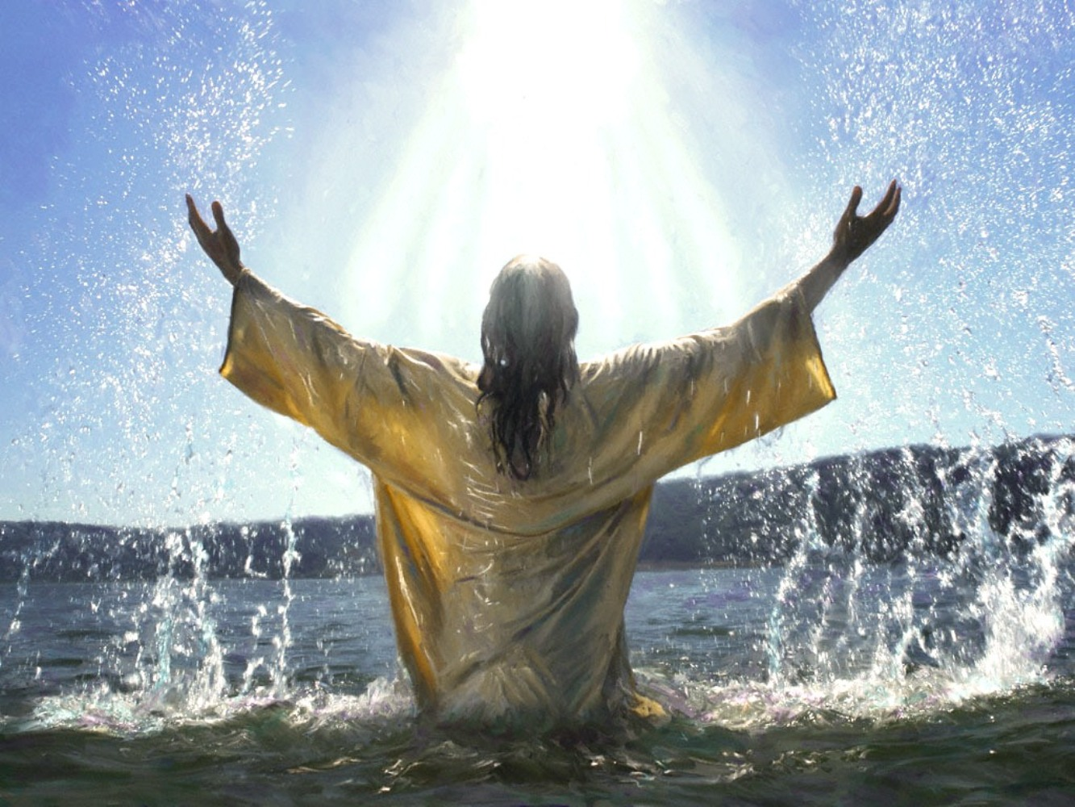

St Peter & St Paul, Deddington

THE GATHERING

Words in bold print are said by everyone.
As we prepare for worship we keep silence

The president says

In the name of the Father, and of the Son,
and of the Holy Spirit.
Amen.

The Greeting

The Lord be with you
and also with you.

Words of welcome or introduction may be said.

Prayers of Preparation

Almighty God,
to whom all hearts be open,
all desires known,
and from whom no secrets are hidden:
Cleanse the thoughts of our hearts
By the inspiration of your Holy Spirit,
That we may perfectly love you,
Ans worthily magnify your holy name. Amen

Prayers of Penitence

Because God was merciful,
he saved us through the water of rebirth
and the renewing power of the Holy Spirit.
But through sin we have fallen away from our baptism.
Let us return to the Lord and renew our faith in his promises
by confessing our sins in penitence.
Father eternal, giver of light and grace,
we have sinned against you and against our neighbour;
in what we have thought,
in what we have said and done,
and in the good we have not done,
through ignorance, through weakness,
through our own deliberate fault.
We have wounded your love,
and marred your image in us.
We are sorry and ashamed,
and repent of all our sins.
For the sake of your Son Jesus Christ, who died for us,
forgive us all that is past;
and lead us out from darkness to walk
as children of light. Amen.

The president declares God’s forgiveness

Almighty God,
who forgives all who truly repent,
have mercy upon you,
pardon and deliver you from all your sins,
confirm and strengthen you in all goodness,
and keep you in life eternal;
through Jesus Christ our Lord. Amen

The Gloria

Glory to God in the highest,
and peace to his people on earth.
Lord God, heavenly King, almighty God and Father,
we worship you, we give you thanks,
we praise you for your glory.
Lord Jesus Christ, only Son of the Father, Lord God, Lamb of God,
you take away the sin of the world:
have mercy on us;
you are seated at the right hand of the Father:
receive our prayer.
For you alone are the Holy One, you alone are the Lord,
you alone are the Most High, Jesus Christ,
with the Holy Spirit,
in the glory of God the Father. Amen
The Collect
Let us pray

THE LITURGY OF THE WORD
The Readings
Everyone SITS
There may be one or two readings from the Bible. At the end of each the reader says:

This is the word of the Lord.

Thanks be to God.

A brief period of silent reflection follows the reading(s)

Gospel Reading
Everyone STANDS when the President stands.

Alleluia, alleluia.
This is my Son, the Beloved, with whom I am well pleased.
Alleluia.

When the Gospel is announced the reader says:

Hear the Gospel of our Lord Jesus Christ according to N.
Glory to you, O Lord.

At the end

This is the Gospel of the Lord.
Praise to you, O Christ .

Sermon

At the end of the sermon a period of silence is kept for reflection.

The Creed

We believe in one God, the Father, the Almighty,
maker of heaven and earth, of all that is, seen and unseen.
We believe in one Lord, Jesus Christ, the only Son of God,
eternally begotten of the Father,
God from God, Light from Light,
true God from true God, begotten, not made,
of one Being with the Father;
through him all things were made.
For us and for our salvation he came down from heaven,
was incarnate from the Holy Spirit and the Virgin Mary
and was made man.
For our sake he was crucified under Pontius Pilate;
he suffered death and was buried.
On the third day he rose again
in accordance with the Scriptures;
he ascended into heaven
and is seated at the right hand of the Father.
He will come again in glory to judge the living and the dead,
and his kingdom will have no end.
We believe in the Holy Spirit, the Lord, the giver of life,
who proceeds from the Father and the Son,
who with the Father and the Son is worshipped and glorified,
who has spoken through the prophets.
We believe in one holy catholic and apostolic Church.
We acknowledge one baptism for the forgiveness of sins.
We look for the resurrection of the dead,
and the life of the world to come. Amen.

Prayers of Intercession
These responses may be used
Lord hear us or Lord, in your mercy,

Lord graciously hear us Hear our prayer

And at the end

Merciful Father,
accept these prayers

for the sake of your Son,
our Saviour Jesus Christ. Amen
THE LITURGY OF THE SACRAMENT
The Peace

We are the body of Christ.
In the one Spirit we were all baptized into one body.
Let us then pursue all that makes for peace
and builds up our common life.

The peace of the Lord be always with you
And also with you.
[Let us offer one another a sign of peace.]

Preparation of the Table

Open the heavens, Holy Spirit,
for us to see Jesus interceding for us;
may we be willing to share his baptism,
ready to share his cup
and strengthened to serve him for ever.
Amen.

The Eucharistic Prayer

The Lord is here

His Spirit is with us
Lift up your hearts

We lift them to the Lord
Let us give thanks to the Lord our God

It is right to give thanks and praise

It is truly right and just,
our duty and our salvation,
always and everywhere to give you thanks,
holy Father, almighty and eternal God.
You celebrated your new gift of baptism
in signs and wonders at the Jordan.
Your voice was heard from heaven
to awaken faith in the presence among us
of your Word made flesh.
Your Spirit was seen as a dove,
revealing Jesus as your servant,
and anointing him with the oil of gladness
to preach the good news to the poor.
Therefore, as we celebrate the union of earth and heaven,
we rejoice to echo the song of the angels in heaven
for ever praising you and saying:

Holy, holy, holy Lord,
God of power and might,
heaven and earth are full of your glory.
Hosanna in the highest.

Blessed is he who comes in the name of the Lord.
Hosanna in the highest.

Lord, you are holy indeed, the source of all holiness;
grant that by the power of your Holy Spirit,
and according to your holy will, these gifts of bread and wine
may be to us the body and blood of our Lord Jesus Christ;

who, in the same night that he was betrayed,
took bread and gave you thanks;
he broke it and gave it to his disciples, saying;
Take, eat; this my body which is given for you;
do this in remembrance of me.

In the same way, after supper
he took the cup and gave you thanks;
he gave it to them, saying; Drink this , all of you;
this is my blood of the new covenant,
which is shed for you and for many for the forgiveness of sins.
Do this, as often as you drink it, in remembrance of me.

Great is the mystery of faith:
Christ has died;
Christ is risen;
Christ will come again.

And so, Father, calling to mind his death on the cross,
his perfect sacrifice made once for the sins of the whole world;
Rejoicing in his mighty resurrection and glorious ascension,
and looking for his coming in glory,
we celebrate this memorial of our redemption.
As we offer you this our sacrifice of praise and thanksgiving,
we bring before you this bread and this cup
and we thank you for counting us worthy
to stand in your presence and serve you.
Send the Holy Spirit on your people
and gather into one in your kingdom
all who share this one bread and one cup,
so that we, in the company of [N and ] all the saints,
may praise and glorify you for ever,
through Jesus Christ our Lord;
by whom, and with whom, and in whom,
in the unity of the Holy Spirit,
all honour and glory be yours, almighty Father,
for ever and ever. Amen

The Lord’s Prayer
Rejoicing in the presence of God here among us,
let us pray with confidence as our Saviour has taught us;

Our Father in heaven
hallowed be your name.
Your Kingdom come, your will be done,
on earth as in heaven.
Give us today our daily bread,
and forgive us our sins
as we forgive those who sin against us.
And lead us not into temptation
but deliver us from evil.
For the kingdom,
the power, and the glory are yours,
now and for ever. Amen.

Breaking of the Bread

We break the bread of life,
and that life is the light of the world.
God here among us,
light in the midst of us,
bring us to light and life.
Giving of Communion
Draw near with faith.
Receive the body of our Lord Jesus
which he gave for you,
and his blood which he shed for you.
Eat and drink in remembrance that he died for you,
and feed on him in your hearts by faith with thanksgiving.

Most merciful Lord,
your love compels us to come in.
Our hands were unclean,
our hearts were unprepared;
we were not fit
even to eat the crumbs from under your table.
But you Lord, are the God of our salvation,
and share your bread with sinners.
So cleanse and feed us
with the body and blood of your Son,
that he may live in s and we in him;
and that we, with the whole company of Christ,
may sit and eat in your kingdom. Amen

Prayer after Communion
Let us pray

Post Communion prayer may be said by the president before the following prayer is said by everyone

Father of all,
we give you thanks and praise,
that when we were still far off
you met us in your Son and brought us home.
Dying and living, he declared your love,
gave us grace, and opened the gate of glory.
May we who share Christ’s body live his risen life;
we who drink his cup bring life to others;
we whom the Spirit lights give light to the world.
Keep us firm in the hope you have set before us,
so we and all your children shall be free,
and the whole earth live to praise your name;
through Christ our Lord. Amen.

The Blessing
May God, who in Christ gives us a spring of water
welling up to eternal life,
perfect in you the image of his glory;
and the blessing …

The Dismissal
Go in peace to love and serve the Lord
In the name of Christ, Amen

